Test Summary Report

Java: Restaurant Gift Card Lookup
Service Application

July 26, 2017
Summer 2017

By: Matt Wilchek

REVISION HISTORY

Version | Date | Organization/Point of Contact | Description of Changes
1.0 | 7/26/2017 | Matt Wilchek | Initial

TABLE OF CONTENTS

1. INTRODUCTION 1
2. REFERENCED DOCUMENTS 1
3. Detailed Test Results 1
3.1 Marathon Integrated Test Summary 1
3.2 JUnit Test Summary 2
4. Recommendations 5

LIST OF TABLES

Table 1: Referenced Documents 1
Table 2: Marathon Test Summary 2
Table 3: JUnit Test Summary 4

LIST OF FIGURES

Figure 1: Create Account Marathon Test…………………………………………………………2
Figure 2: Around You Marathon Test……………………………...……………………………..3
Figure 3: Get Directions Marathon Test……………………………...…………………………...3
Figure 4: Indexed List Test………………………………………….......………………………...5
Figure 5: Ordered List Test……………………………………………………………...………...6
Figure 6: Read Excel Document Test……………………………………………...…………...…7
Figure 7: Binary Search Tree Test…………………………………………………...……………8
Figure 8: Heap to Graph Test…………………………………………………………...…………9
Figure 9: Ant Colony Optimization Algorithm Test……………………………………..………10

INTRODUCTION
The Java Restaurant Gift Card Lookup Service Application is used for 2 purposes. One, give a platform for local restaurant establishments to advertise their venue. And two, allow public users to find local restaurant establishments around their location that offer the purchase for gift cards. This report contains documentation on the successful application tests for this program. This summary report also includes the summary of each test cases by class and method using the techniques and the tools such as JUnit and Marathon integration testing.

REFERENCED DOCUMENTS

Table 1 Referenced Documents
Document Name | Issuance Date
Project Requirements | July 25, 2017
Java Doc | July 25, 2017
UML Diagram | July 25, 2017
Appendix A: Marathon Integrated Test Cases | July 25, 2017
Appendix B: Junit Test Cases | July 25, 2017
Java Restaurant Gift Card Lookup Service Application | July 25, 2017

Detailed Test Results
The testing summary reports of Marathon integrated test cases and JUnit tests are provided below.

3.1 Marathon Integrated Test Summary
The table below summarizes the test cases employed for Marathon integrated testing and the test results obtained for each test case can be found on Appendix A.

Table 1: Test Summary
Test Class | Number of Test Cases | Number of PASS | Number of FAIL | Pass Percentage | Fail Percentage
Create Account Integrated Test Case:  Checkout Functional Requirements | 3 | 3 | 0 | 100% | 0%
Filter Dataset by Location:  Checkout Functionality | 5 | 4 | 1 | 80% | 10%
Get Directions from Location A to B:  User Interface and Checkout Functionality | 3 | 3 | 0 | 100% | 0%
Total | 11 | 10 | 1 | 91% | 9%

There are 11 test cases and10 of the test cases are pass. The calculated level of success for Marathon integrated testing is 90.90%.

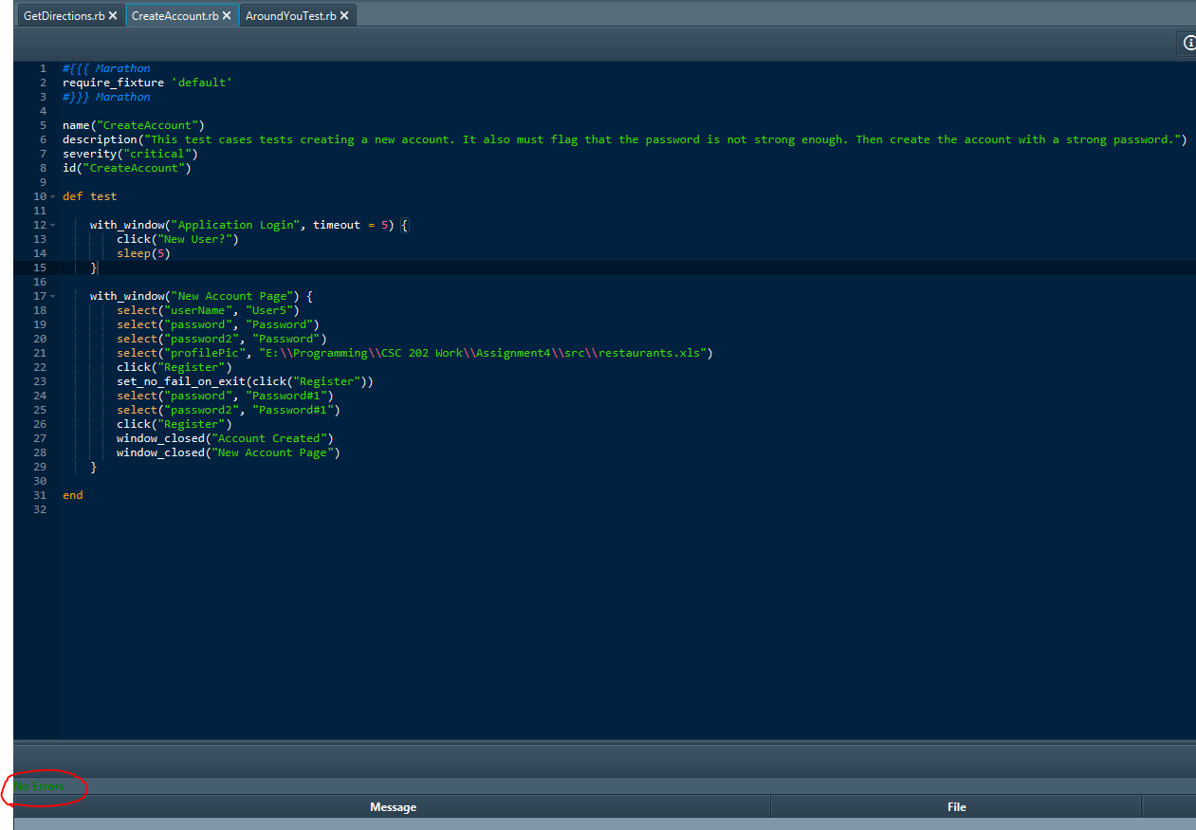
Figure 1: Create Account Marathon Test

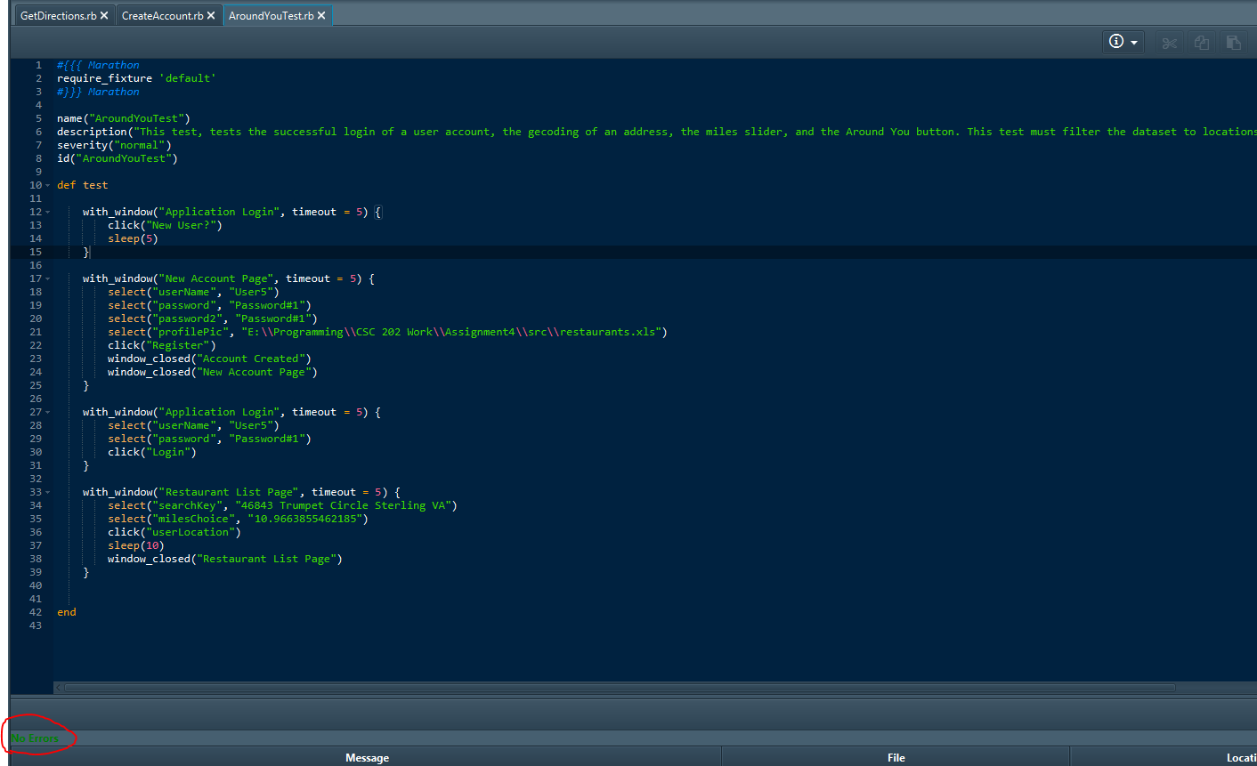
Figure 2: Around You Marathon Test

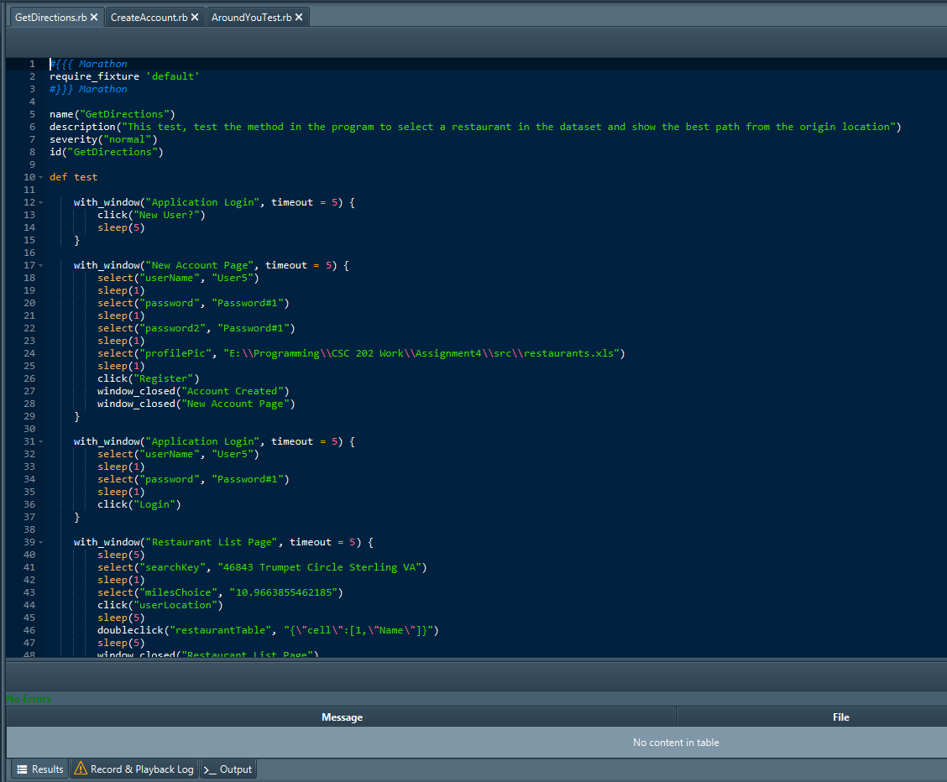
Figure 3: Get Directions Marathon Test

3.2 JUnit Test Summary
The table below summarizes the test cases employed for JUnit and the test results obtained for each test case:

Table 2: JUnit Test Summary
Test Class | Number of Test Cases | Number of PASS | Number of FAIL | Pass Percentage | Fail Percentage
Indexed List | 11 | 11 | 0 | 100% | 0%
Ordered List | 9 | 9 | 0 | 100% | 0%
Read Excel Document | 1 | 1 | 0 | 100% | 0%
Binary Search Tree | 8 | 8 | 0 | 100% | 0%
Heap to Graph | 9 | 9 | 0 | 100% | 0%
ACO Algorithm | 2 | 2 | 0 | 100% | 0%
Total | 40 | 40 | 0 | 100% | 0%

There are 40 test cases and 40 of the test cases are pass. The calculated level of success for JUnit test is 100%. Figures 1 through 6 show the results of Indexed List, Ordered List, Read Excel Document, Binary Search Tree, Heap to Graph, and Ant Colony Optimization Algorithm Junit test results.

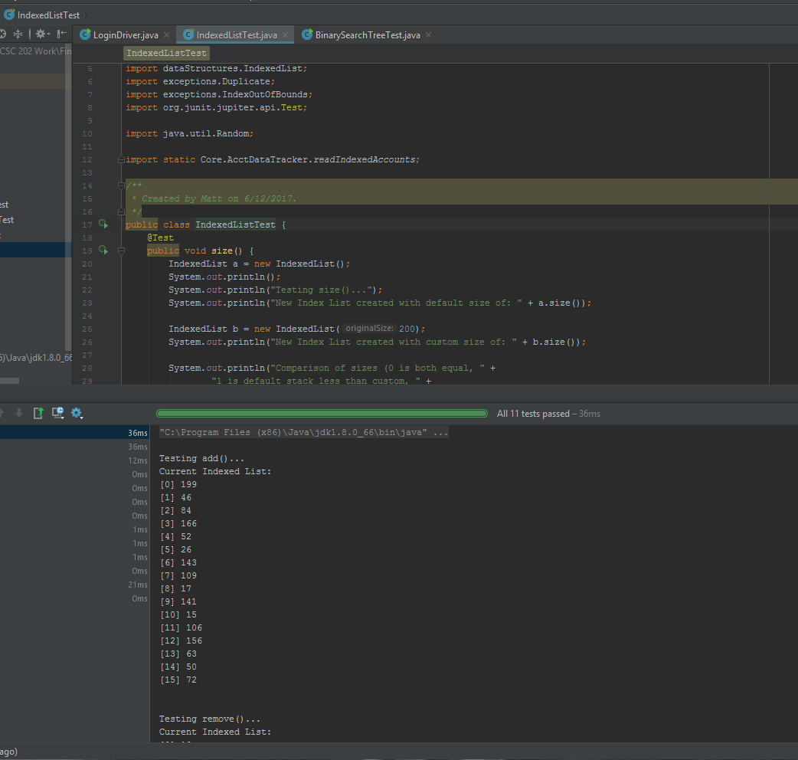
Figure 1: Indexed List
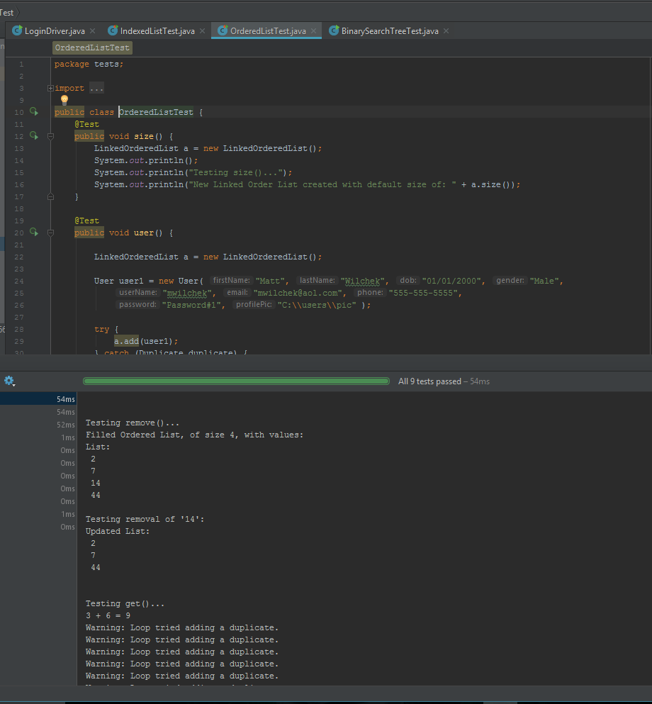
Figure 2: Ordered List

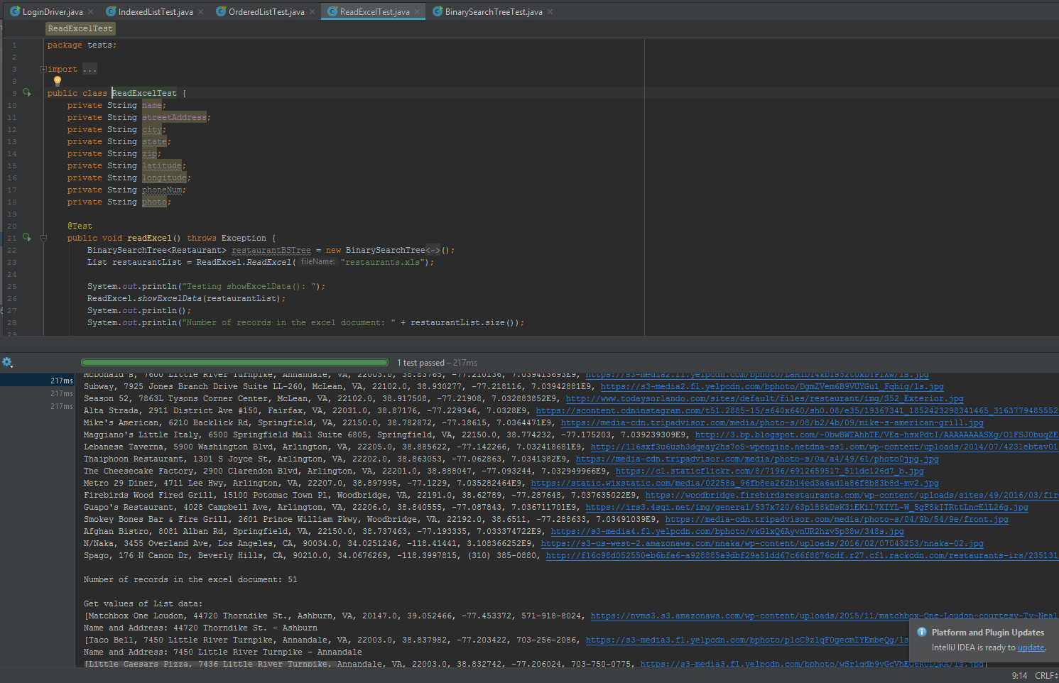
Figure 3: Read Excel Document Test
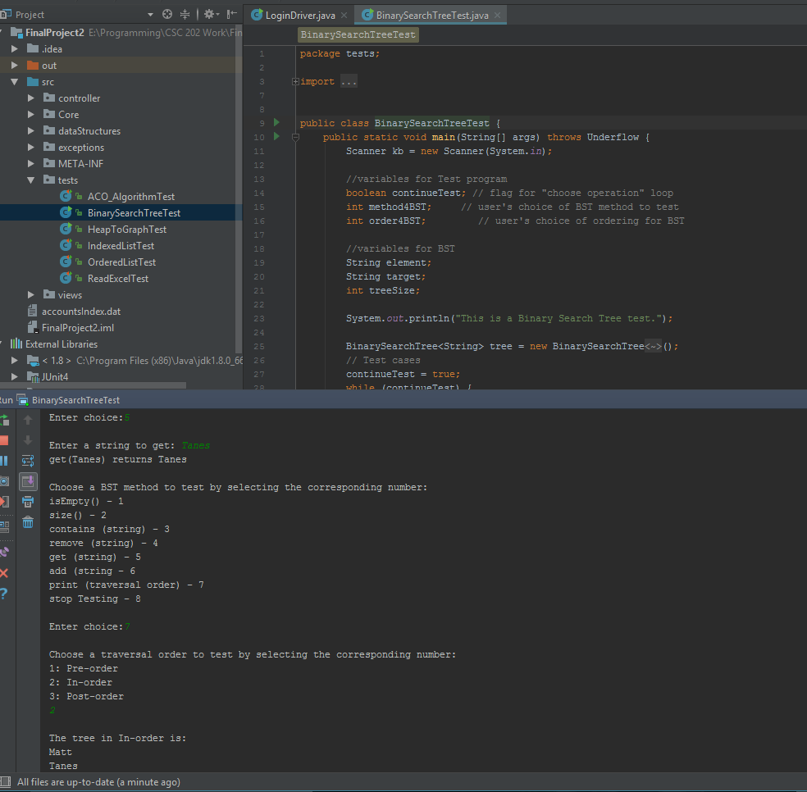
Figure 4: Binary Search Tree Test

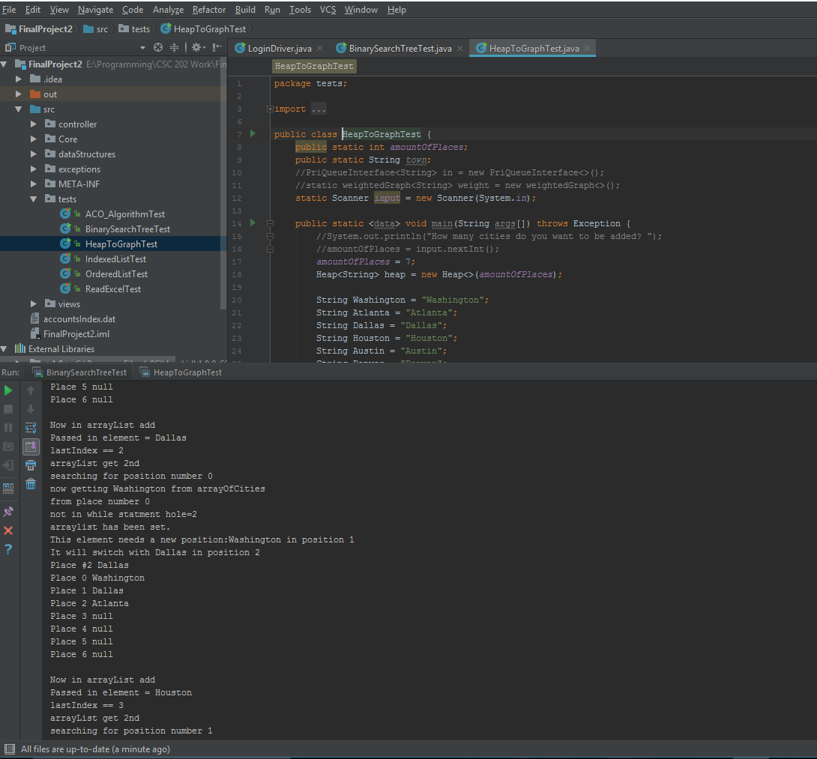
Figure 5: Heap to Graph Test

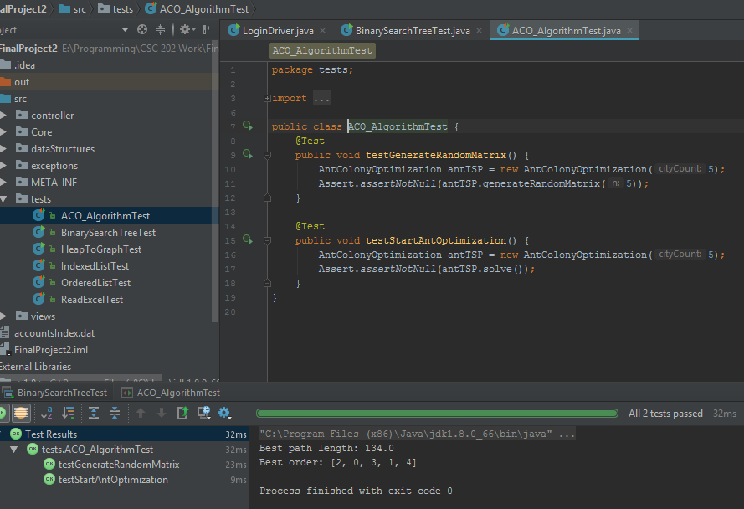
Figure 6: Ant Colony Optimization (ACO) Algorithm Test

Recommendations
The Java Restaurant Gift Card Lookup Service Application must be fixed for the fail cases before moving on to the production as well as successful publication to the web and added signed certificates. The design of the tool may also be slightly redesigned to make it more professional with added payment processing for gift card purchases via web/php scripts. The tool should have additional complexity business metrics for restaurant establishments to track gift card purchases; most likely through publish Tableau dashboards.

